**Alumni Reunion and Golf Outing**

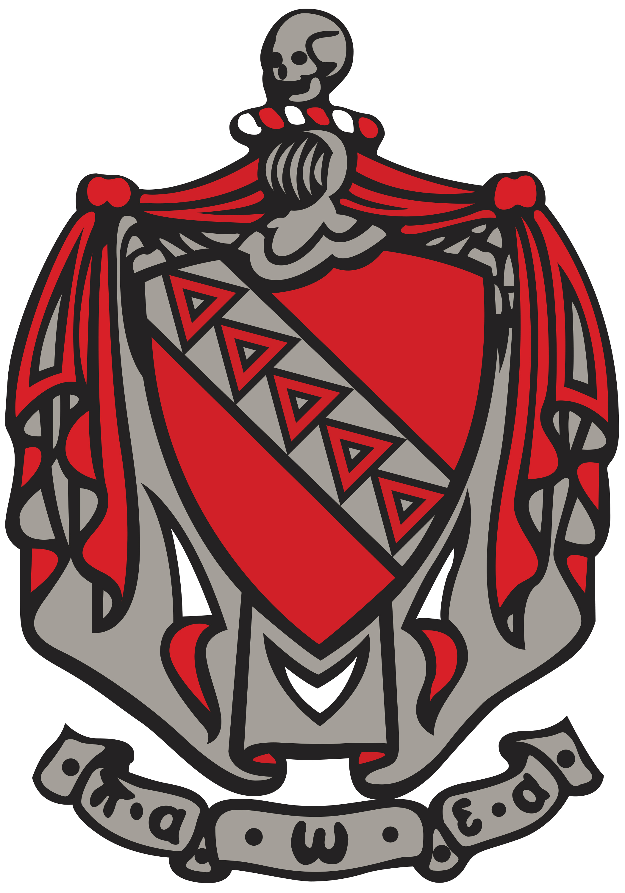

Alpha Nu

April 2018

Saturday, April 28th we will be having our annual reunion at Libby’s in downtown Durham beginning at 5 pm. This year we will be having our First Annual Golf Event to go along with the Libby’s event. The golf event will take place at Pease Golf Course with a shotgun start time of 8:30 am on April 28th. The winner of the golf event will take home a pair of red sox tickets! You can follow the link below to register for the Alumni Reunion, and can find the paypal information under a prior post by Vinnie LoBuono in order to pay $74 for the golf outing.

<https://www.memberplanet.com/events/anaatke/anreunion2018>

# Spring Highlights:

# Philanthropy

**We hosted what we hope to become an annual event with our Spring Talent Show this past Saturday in the Granite State Room of the MUB. We continue to tirelessly work toward our goal of $20,000 for St. Jude’s.**

# Miscellaneous

## We are attending the New England Revolution game against the Montreal Impact on Friday, April 6th as a brotherhood event.

## Our annual Red Carnation Ball will be held at Village By the Sea in Wells, ME.

## We helped raise over $150 for Frater Dave Lefcourt’s daughters Girl Scout Troop through their annual girl scout cookie fundraiser