Introduction
“Better Men for a Better World”

Tau Kappa

Epsilon Newsletter
The year 2018-2019 was an extreme accomplishment for Sigma-Theta. Because of the excessively large class total of 17, TKE as a result completely influenced Saint Leo University more than any other organization on campus. To capitalize off of our success, our new Executive Board and Committee Chairmen are all in great standing and ready to fully prepare incoming members and continue to grow the Sigma-Theta chapter.

The New Executive Board Officers
  - SIGMA THETA
17 October 2019
Last semester was a very successful year for the previous Executive Board, as they had much influence on the chapter and how it has operated. With the new Executive Board being elected, it is now our obligation to take charge and continue to spread that influence. For those who are unfamiliar with the new Executive Board of Sigma-Theta, here is a list as well as everyone’s contact information:
- Prytanis: Austin Wentz – austin.wentz@email.saintleo.edu
- Epiprytanis: Zachary Smith – Zachary.smith09@email.saintleo.edu
- Grammateus: Tyler Bourdeau – Tyler.Bourdeau@email.saintleo.edu
- Histor: Peter C. Pappalardo – peter.pappalardo@saintleo.edu
- Cyrsopholos: Eduard De La Luz – Eduard.delaluz@email.saintleo.edu
- Hypophetes: John-Paul West – jprock134@gmail.com
- Pylortes: Mike Kiernan – Mkiernan1097@gmail.com
- Hegemon: Christopher Kosarzycki – chriskosarzycki@gmail.com

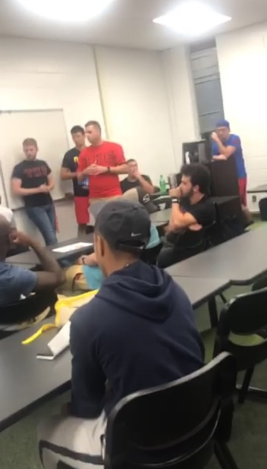
Potential Plans for Alumni Weekend
Currently alumni dates are set in stone yet. However, Histor Peter Pappalardo is still in coordination with Prytanis Austin Wentz and Hegemon Christopher Kosarzycki so that the alumni can attend on the best possible dates along with an advanced notice. There will be two alumni weekends per semester this year, giving a total of four weekend celebrations. For both semesters, one weekend will be dedicated to an alumni softball game against another TKE chapter, and the other will be a mid-process alumni weekend, to help promote interviews within the new class. There are no finalized dates at the moment, however, they will be presented once a final decision has been made between the Executive Board.

Conclave
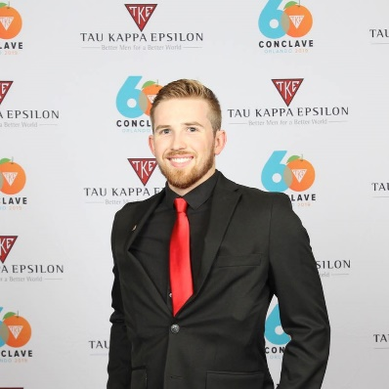
Over our last summer break, Frater Prytanis Austin Wentz managed to make his way to Conclave and represent our organization! Congratulations Austin!
”Going to conclave was an incredible experience.”
– Austin Wentz

TKE Leadership Conference

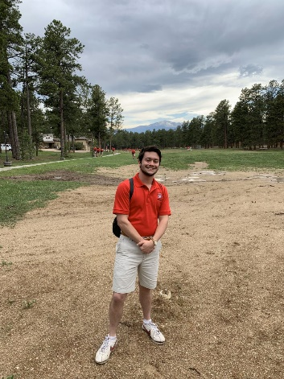
Frater Christian Toucey (Our Judicial Chair) represented the Sigma-Theta chapter at the TKE Leadership Conference on the days of May 28th – June 4th. Christian Toucey has much passion for the TKE organization and was easily one of our best members to attend this event.

“It was life-changing. I learned a lot about myself and the guys around me. I also learned more about the fraternity and what it truly means to be TKE.” - Christian Toucey
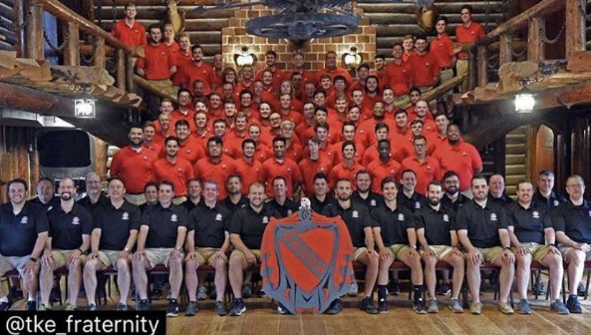

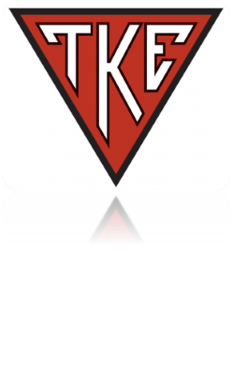
TKE Foundation Scholarships
Frater Maxwell Kesewiski received a national scholarship from the TEF. The scholarship was worth $700. This has significantly helped Max with his college career, and he is therefore super thankful for it.
“Honestly, I was shocked. There are a lot of smart TKEs in the TKE Nation and I was surprised that they chose me out of everyone there. It really was an honor and I’m thankful to the donor that helped me with my education!”
– Maxwell Kizewski

Notable Awards

Upon graduation of Saint Leo, now-alumni member Christopher Daniello has received an award for being the best recruiter of Tau Kappa Epsilon! Chris’s incredible success helps represent Sigma-Theta once more!
“Just work hard instead of talking shit. It’s too easy, but you just got to give the effort. I may have gotten the award, but it took the entire organization to make it work.”
– Christopher Daniello

Frater Jared DeWinne has gotten a special mention and will soon receive an award for achieving the highest GPA during his TKE process. He was also the highest on scroll for his class! Keep in mind that the Alpha Epsilons had a class total of seventeen members. Jared’s GPA was a 3.95.
“When I set my mind to success, along with consistent help from my brothers, every accomplishment I desired was possible.”
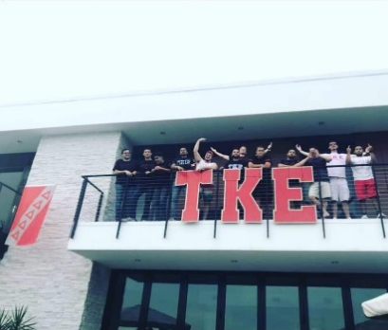
– Jared DeWinne

Rush Week
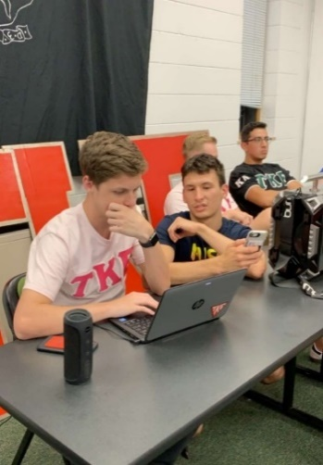
Our final rush week schedule was set in stone one week before the events. With that being said, tons of planning was involved.
Monday: Our experience at the Brag Tables this semester was fairly successful. The chapter managed to get contact info of nearly 20 guys. Most have been pointed to the flyer which helped in referring them our follow-up event on Tuesday.
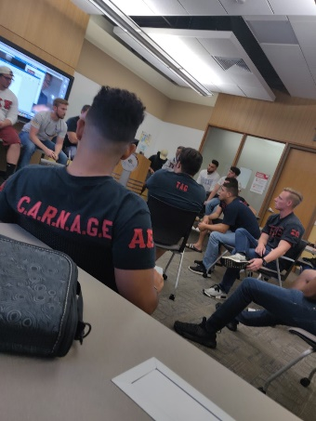
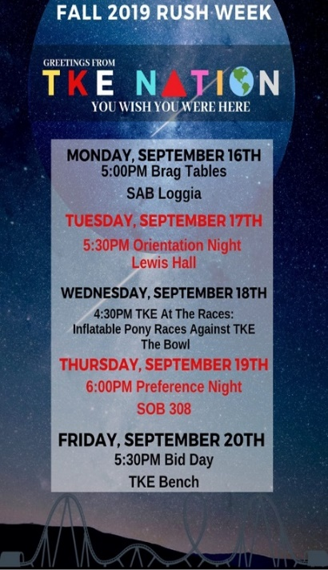
Tuesday: Orientation was a professional event that helped further explain our organization. For some of the Epsilon class, it was an experience that they can utilize to present themselves, so that they can become the new faces of TKE. There were about five groups, and each group had roughly 20-minute rotations. Alumni members Kevin Penaranda and Ryan Bourdeau showed up to help support our cause.
Wednesday: Wednesday’s event was TKE at the Races (Pony Races at the Bowl). Thanks to Bradley and his sincere number of people he knows, an inflatable balloon race was brought here from a place located more than an hour away. This took many guys to help set up, and as a result, many people came out to hang with TKE. Free ice-pops were also handed out for those who managed to show.
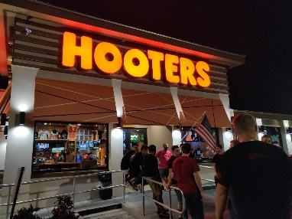
Thursday: Preference Night was executed in the School of Business this semester. A total of 12 out of 15 invited guys managed to show, each with a humorous interview. The majority of voting was extremely positive. Chapter Advisor Carlos Ramos was also present during this event.
Friday: Bid day officially started at 8:00 a.m., and every single voted person received a bid. Of the 12 new guys wanting to rush, 8 chose to accept our bid. Therefore, Sigma-theta once again received the biggest rush class of the semester. At 5:30, we celebrated traditionally by going to our bench and taking a picture. The chapter then went to Hooters to finish the celebration. A total of 6 alumni also managed to attend the Hooters follow-up event!
First Retreat of 2019-2020
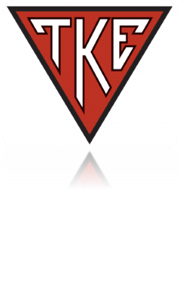
Frater Hypophetes John-Paul West had our retreat event on October 6th from 4:45 P.M. – 9:25 P.M. Our chapter almost had a full turnout as a result. John-Paul developed a few activities to help introduce the importance of knowing one another. Icebreakers were our primary source of getting everyone’s soft spots exposed. Our two main activities were Two Truths and a Lie and explaining our biggest fear. We finished off our retreat with the longest portion of the event, which was explaining our feelings towards one another. This retreat left the chapter with lots of weight taken off everyone’s shoulders and therefore keeps the chapter in a much more mentally healthy state.
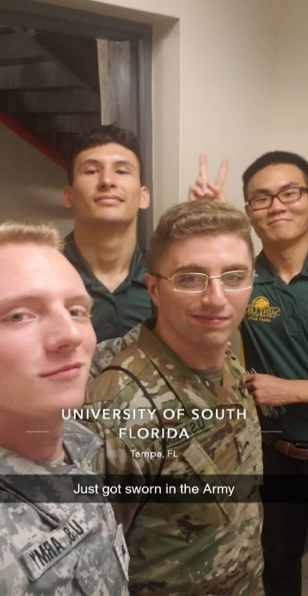
Donation Acknowledgement
Chapter advisor Kevin Sullivan made a special announcement to help fund Sigma-Theta’s Rush Week. Frater Cryso’ Eduard De La Luz reported that because of Kevin’s 30-for-30 idea (in regards to our 30th anniversary on campus), our chapter received a total of $821 in donations just from alumni! This generosity will not go unnoticed, as the chapter was extremely thankful for every single bit.
New ROTC Contracted Cadets! – ROTKE Rebirth
Please congratulate fraters Peter Pappalardo, Christopher Kosarzycki, Gabriel Schroeder, and new Alpha-zeta class members David Lee and Blake Burman as they all have officially been sworn into the United States Army to later be recognized as lieutenants. As a result of the huge influx of ROTC cadets within Sigma-theta, frater Christopher Kosarzycki will be returning the ROTKE as a reminder of TKE’s military-friendly environment. Exclusive letters will also be produced to help support the cause!
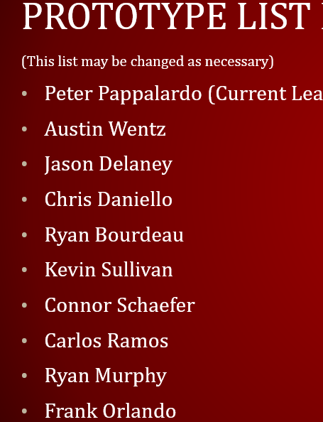
Alumni Foundation Association Announcement
Frater Histor Peter Pappalardo and Prytanis Austin Wentz made an official announcement during the first chapter meeting of the year in regards to a long-lost footing of what is known as the Alumni Foundation Association. This project’s main purpose is to help maintain a better relationship with our past members as the chapter continues to move forward. At our third chapter meeting, Histor Peter Pappalardo had a PowerPoint presentation in regards to the start of the AFA’s development. This gave information regarding what is the AFA, how does it work, and what the future of Sigma-theta’s AFA may look like. A prototype list of alumni members was also given during this presentation to explain the starting Board members of the AFA. There is no say in how successful this project will be, but as long as both parties are continuously on board, alumni are bound to have far greater relationships, connections, and support with the current chapter. More information to come, so stay tuned!
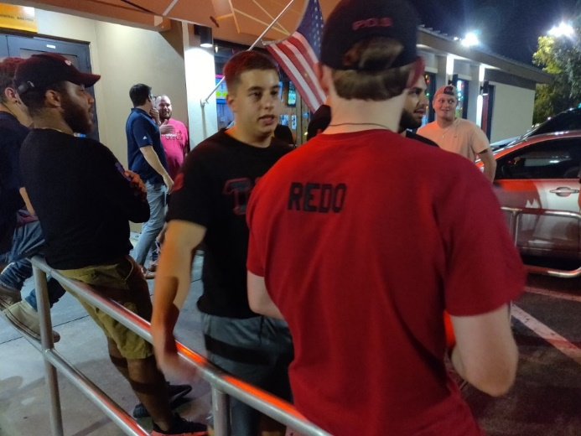
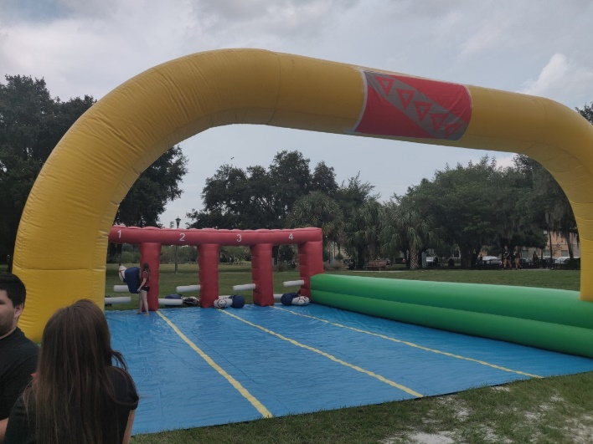
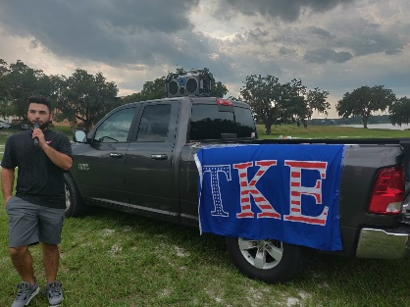
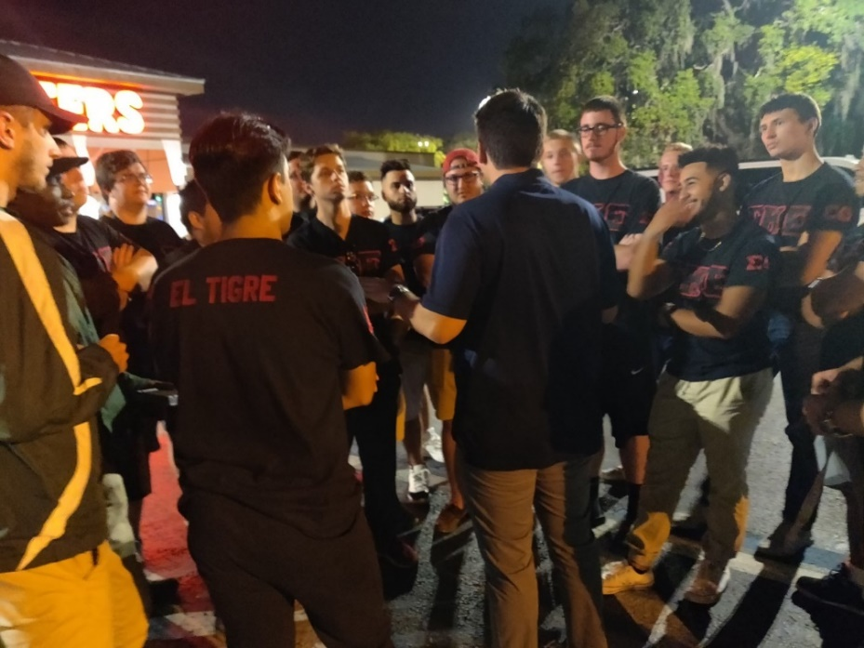

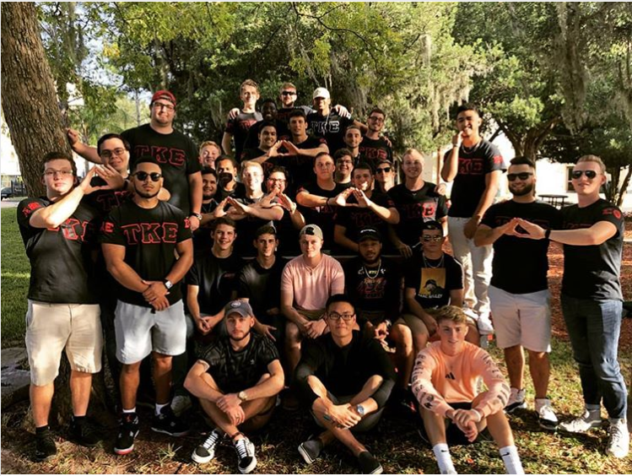
Welcome to TKE Alpha-Zeta Class
Blake Burman, Mathew Romano, Calvin Davis, Angelo Alessandro,
Ryan Freeman, Dolton Scott, David Lee and Colton Point

End of Newsletter

