Introduction
“Better Men for a Better World”

Tau Kappa

Epsilon Newsletter
One more semester down and yet another one to go. The Sigma-Theta chapter has had plenty of changes throughout this last semester. Alpha-Zeta’s have just been initiated into the organization, the executive board had some adjustments, chairs had some tunings through leadership, and even a few awards were given.

The Adjusted Executive Board Officers
  - SIGMA THETA
08 December 2019
The executive put forth great effort to maintain order this semester, but the fun doesn’t end here as the board still has one more semester to go. Changes were made, however that doesn’t prevent us from moving forward. With no other deviations to be made next semester, this leaves us in a more comfortable spot so all executions of our plans can be done fluently and efficiently. Frater Jared Dewinne will be taking role of Epiprytanis as former Epiprytanis Zachary Smith will be taking role of Prytanis. Here are our updated contact information emails.

- Prytanis: Zachary Smith – Zachary.smith09@email.saintleo.edu
- Epiprytanis: Jared Dewinne – Jared.dewinne@email.saintleo.edu
- Grammateus: Tyler Bourdeau – Tyler.Bourdeau@email.saintleo.edu
- Histor: Peter C. Pappalardo – peter.pappalardo@saintleo.edu
- Cyrsopholos: Eduard De La Luz – Eduard.delaluz@email.saintleo.edu
- Hypophetes: John-Paul West – jprock134@gmail.com
- Pylortes: Mike Kiernan – Mkiernan1097@gmail.com
- Hegemon: Christopher Kosarzycki – chriskosarzycki@gmail.com

A Semester of Transition
The Fall Semester of 2019 has been a fairly difficult era for the Sigma-Theta chapter. As necessary, our chapter has adapted to our difficulties and continued to move forward. Maintaining order was one of the issues during this timeframe. To prevent those issues going further, Prytanis Zachary Smith shared with the board prior to Chapter that there will now be a new “Points” system to help maintain responsibility for not just leadership, but for all actives of the Sigma-Theta chapter. These points will act as a motivational guideline, so actives continue to stay obligated to the chapter’s practices. Our Grammateus Tyler Bourdeau has taken control of keeping track of each frater’s points. The system will go as follows:
- 1 point for wearing correct dress uniform
- 1 point for wearing letters
- 1 point for attending events that are mandatory and/or optional
- 5 points for paying all your dues and extra costs such fines and shirts
- 5 point for having a 3.0 and 1 point for every .2 higher
- 5 points for getting 20 community service hours and 1 point for every 10 above
- 5 point for every 20 dollars donated to Saint Jude and 1 point for every 5 dollars above
- 1 point for attending or donating to a different organization
- 1 point for attending chapter and any rituals
Actives are required to send pictures as proof to the Grammateus (poor Tyler’s phone has blown up beyond belief). The top five fraters in regards to the most points will have special rewards. Some include free RCB tickets, Custom-made letters of choosing, and even half-off a frater’s dues!
The reverse is also true, where there is also a list of penalties for actives that do not follow or obey the laws of the chapter. Consequences such as being suspended will be enforced as necessary (being the worst case scenario). Understand that this system was just implemented. Therefore, it may change as time moves forward.

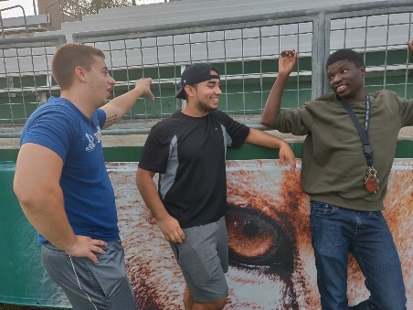
Potential Plans for Alumni Weekend
Due to unsteady beginning of the semester, this semester’s alumni weekends have been cut and altered with little-to-no-notice. Next semester, we as a Board want all plans finalized far in advanced this way preparation goes much smoother. For alumni weekend, Histor Peter Pappalardo decided to once again use two alumni weekends February 28th-29th April 17th-19th. All alumni should take note of these two weekends. If dates are due to change, alumni will be notified as necessary.

Captain of the Sea (The First Mate)
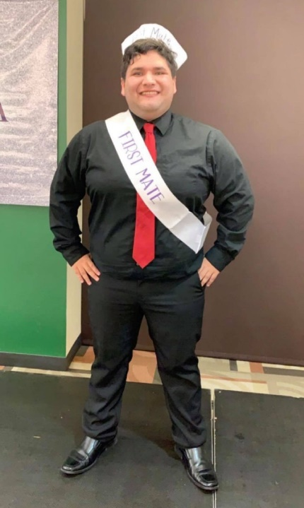
The Tri-Sigma Sorority hosted their traditional event “Captain of the Sea” this semester, which is a competition to show who is the most talented and sincere individual in regards to their organization. Sigma-Theta had two contestants for this event: Fraters Andy Escalera (alpha-epsilon class) and frater Eduard De La Luz (alpha-gamma class). While there was a wide variety of performances, Andy Escalera’s performance was outstanding, as he had a great way with words and even some dance moves! Andy had received the second-place equivalent known as “The First Mate”.
“I was the underdog going into it because my relationship with the Sigma’s were not as strong as some other contestants, but overall going into it I knew I had to do my best and let God do the rest. After dancing and seeing everyone’s reaction to my talent I felt confident. However, I knew the last round would count a lot so I had to answer from my heart when I answered about women empowerment and I would say I did well and made the judges cry to an extent that I was emotional. Not just to the fact on the result of the pageant but also the fact that I poured my heart out and my house burned down. It was a rough week and I prepared for the worst and hoped for the best. Tension was going through me when they announced the first mate and I saw the person gaze upon me before announcing the first mate and I knew I got second. After the fact I do not know why people were happy for me because I originally thought there could only be one winner and if you are not first you are last. At the end of the day I was reassured that I was still able to go to events and be associated with the sorority. I plan on going out again next year and placing first and I appreciate the brothers who supported me throughout the pageant.”
- Andy Escalera

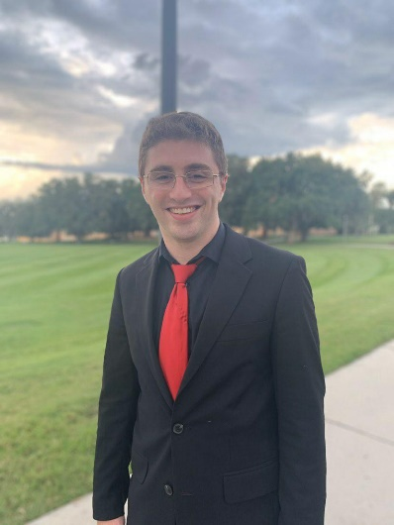
Esports (Super Smash Bros. Tournament)
Histor Peter Pappalardo had taken place in a Saint Leo Esports tournament featuring the videogame “Super Smash Bros”. The majority of the chapter had shown up to express their support. Alumni Christopher Daniello also showed up. As a result, Peter Pappalardo had gotten second place after a long series of competitive matches.
“Having the guys show up was extremely encouraging, especially when they know I enjoy playing this game competitively. For the game’s they did watch, their support was the motivation I needed to get as far as I did. In the end, it’s just a game, but them being there shows how much we care for one another.”
– Peter Pappalardo

Donald Tapia Award (School of Business Picture)
Famous American businessman Donald R. Tapia, United States Ambassador to Jamaica and famous Tau Kappa Epsilon alumni, has received an award at Saint Leo University for philanthropy. To compliment his award at our campus, the Sigma-Theta chapter made sure to take a picture in front of the school with Saint Leo’s president to help express the importance of this award. The chapter will always show love and support for Donald Tapia and his great efforts.
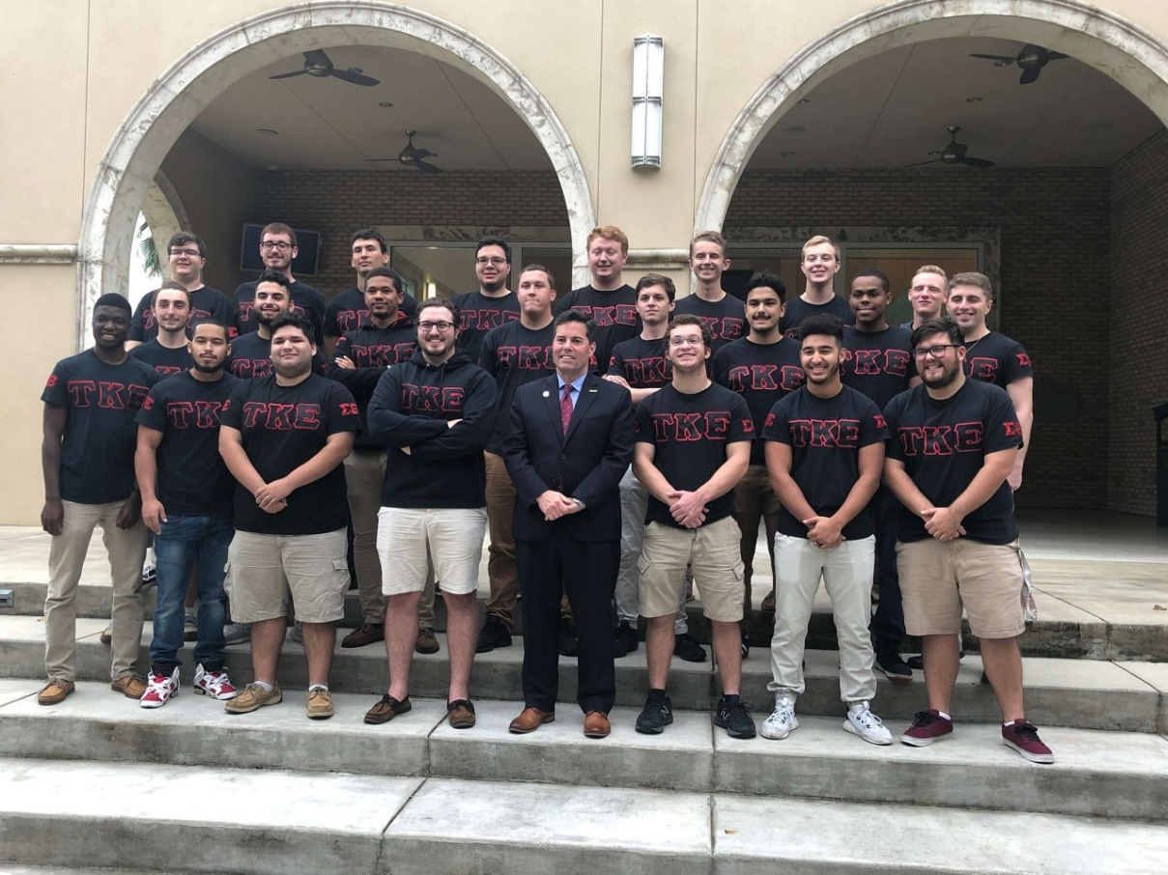

Chair Position Updates
With a huge transition of our executive board, our chair positions were also affected as a result. New Epiprytanis Jared Dewinne has made sure to however keep each chair position on their toes. This is so each chair can maintain responsibility and continue to move forward with the new executive board. With all being said, Epiprytanis Jared Dewinne has lots of information to explain the current standing of each chair (except Philanthropy and Webmaster chairs which have not taken affect yet).
“As Epiprytanis of the Sigma Theta Chapter of Tau Kappa Epsilon, I am blessed to have such amazing chairs to work with for this year. We've had nothing less of a shaky start, but to conclude the end of this semester, I am confident that we will get back on the game for the new year. Below are some words that give a small update on how each chair is doing, and what happened (or didn't) this semester.”
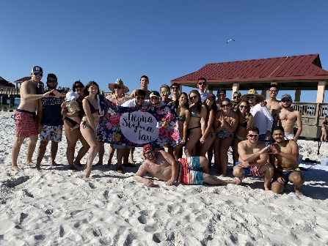
- Jared Dewinne
Social Chair: We had two socials, one with Alpha Sigma Tau at the Clearwater beach, and another with Tri-Sigma in Kirk Hall. Both socials reminded us what Greek life was all about and were able to happen thanks to the planning of both organizations' social chairs and eBoard members. Next semester we look to have a social with all Panhellenic sororities and also a UGC (preferable Sigma Gamma Rho). Hopefully, Bradley will be able to have exciting events, suited for each organization.
Rush Chair: We brought in eight significant pledges thanks to the efforts of Bradley Pincus and were able to spread the word. Starting from the first rush week event to the last, Bradley, along with the help of many active members, ensured the lifeblood of the fraternity continued to impact other young men.
J-Board: Christian at first was very lenient to the active members who disobeyed particular bylaws such as dress clothes on Tuesdays, but after close examination, finally handed out punishments. While any sanction is not desired, it is essential that the values which we believe must be upheld, no matter the cost. These traditions are such to prove once again to ourselves and those outside our organization that we truly live by "Better Men for a Better World.
Athletic Chair: Brennan has made some interesting calls, to say the least, but we took home a few championships, including Men's Softball and Frisbee tournament. Hopefully, next semester Brennan will realize that while he is the captain, he is not the best player on the field.
Fundraising Chair: We have not done anything for this yet but have many plans for next semester. It is up to Thomas Ivey to make this happen, and for the rest of the chapter to support his efforts.
Community Service: Charles has informed the chapter of a few community service events yet was still unable to get in touch with the main gal for us to Adopt a Road. Thanks to new requirements, we must have 10 hours submitted by January, per active member. We look forward to having large events such as the circle of veterans, and potentially with alumni members of our chapter.

Congratulations Alpha-Zeta Class!
Originally educating a total of eight new members, Hegemon Christopher Kosarzycki managed to successfully bring the four remaining initiates into the chapter. The other four had dropped due to their respective reasonings. There were no hard feelings brought to the members who chose not to finish. The Sigma-Theta chapter is very pleased to have these four great men officially be apart of our great organization. Congratulations David Lee, Mathew Romano, Ryan Freeman, and Angelo Alessandro!

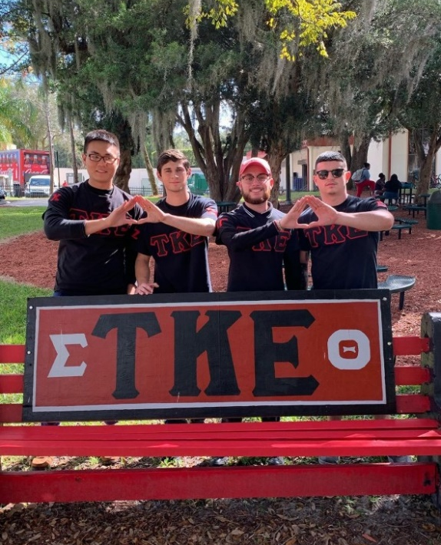

End of Newsletter

