Introduction
“Better Men for a Better World”

Tau Kappa

Epsilon Newsletter
The year 2020 consisted of a significant changeover for our chapter. Alpha-Eta’s class has just started their process, the executive board had some adjustments, many events were completed with thrilling success, and our presence on campus has grown once more.

Executive Officer Contact Information
  - SIGMA THETA
29 Februrary 2020
For updates on the board, frater Gabriel Schroeder has taken the position of Pylortes. Please contact him if necessary as he now assumes the responsibilities of our risk management.

- Prytanis: Zachary Smith – Zachary.smith09@email.saintleo.edu
- Epiprytanis: Jared Dewinne – Jared.dewinne@email.saintleo.edu
- Grammateus: Tyler Bourdeau – Tyler.Bourdeau@email.saintleo.edu
- Histor: Peter C. Pappalardo – peter.pappalardo@saintleo.edu
- Cyrsopholos: Eduard De La Luz – Eduard.delaluz@email.saintleo.edu
- Hypophetes: John-Paul West – jprock134@gmail.com
- Pylortes: Gabriel Schroeder – gabriel.schroeder@email.saintleo.edu
- Hegemon: Christopher Kosarzycki – chriskosarzycki@gmail.com

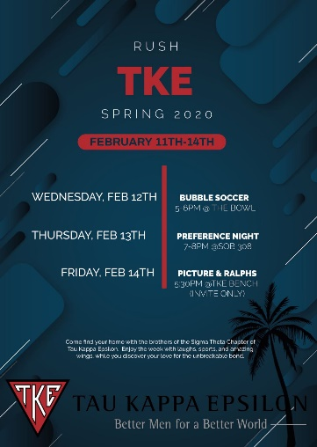
Rush Week of Spring 2020
While last semester consisted of a major transition phase, the Sigma Theta chapter had a very successful rush week this season. For this semester, our schedule was much more active to the point where others not wishing to be apart of Greek Life came along to support the cause. The schedule went as follows:
- Monday: Barbeque up the Hill (Marmion 7:00 P.M.)
- Tuesday: Orientation Night (Selby 6:00-8:00 P.M.)
- Wednesday: Bubble Soccer (Bowl 5:00-6:00 P.M.)
- Thursday: Preference Night (SOB 7:00-8:00 P.M.)
- Friday: Pictures and Ralphs (TKE Bench 5:30 P.M.)

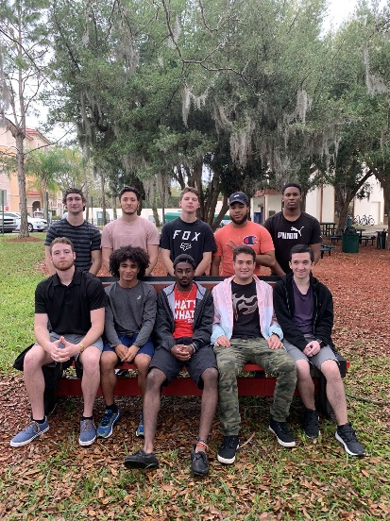
New Alpha-Eta Class
Thanks to a fantastic rush week, Sigma Theta was able to recruit a very balanced class of both quality and quantity of men. For this semester, we recruited a total of ten candidates, two of which are returning from last semester’s class! This means we have acquired eight brand new faces across our chapter’s community. Hegemon Christopher Kosarzycki is very happy with the new class he has received this semester and believes it was one of the best classes Sigma Theta has ever had. The new class consists of Seth, Kaemon, D’Angelo, Jett, Elija, Mathew, Malcolm, Blake, Calvin, Emanuel, and Anthony.

Andy’s Barbeque (Monday’s Rush Event)
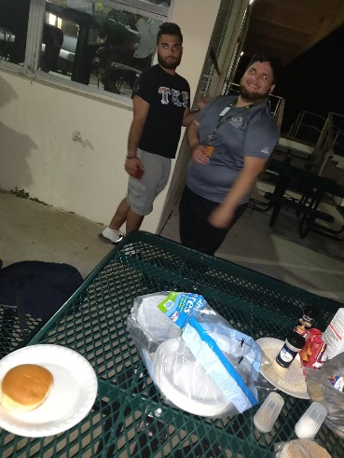
For Monday’s event, frater Andy Escalera took charge and coordinated the chapter on showing face to the freshman on the other end of campus (Marmion and Snyder Halls). This not only introduced TKE to those who aren’t familiar with Greek Life, but it raised our awareness across campus too. The Barbeque was an amazing success, and it brought out many individuals, both male and female to meet many great men from the organization. The chapter made sure to show appreciation of Andy as he balances his new R.A. position and his involvement in TKE.
“I felt like it was a success. Over 50 people showed up, and freshmen enjoyed hanging out with TKE. Our fraternity gave them a warm welcome by providing hotdogs, hamburgers, chips, and drinks. TKE was the only fraternity that made the initiative to go to Marmion and Snyder Halls to hang out with the residents, and fellow fraters need to continue to do this to build the connection continuously”. – Andy Escalera

Dye-A-TKE (Saint Jude Awareness)
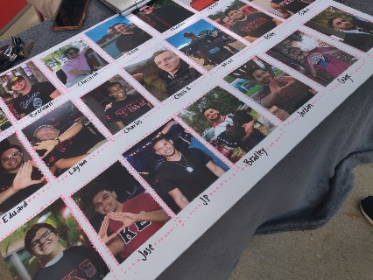
Our organization is known for having a very sincere connection to Saint Jude. To further our connection, philanthropy chair Evin Martinez has overlooked the concurrent Dye-A-TKE event and proposed the event would last for a total of 10 days. At the moment of this submission, there is a total of $1378 raised. Chapter advisor Frank Orlando currently takes the lead with $578 raised. The chapter has a goal of $2000 raised, and Frank stated he would donate 500 additional dollars if the chapter gets to 1500 dollars from what we currently have acquired. Compared to Sigma theta’s previous near $400 donation, this is an insane gap increase!

Dunk-A-TKE
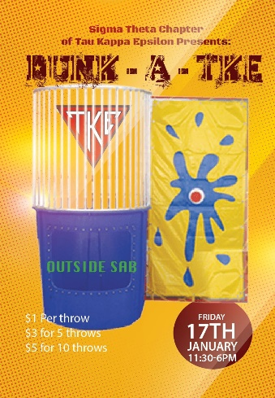
At the beginning of the semester, the chapter immediately sought out an event and we decided on Dunk-A-TKE, which ultimately involved dunking actives within a dunk tank! This event took place on January 17th, and it lasted 6 hours. While Florida was hotter than ever (even though it was January) the water was freezing! Due to the tremendous success of the event throughout the day, alumni and economics professor Ryan Murphey came to the tank and also managed to get dunked too! And if that wasn’t enough, Saint Leo president Jeffrey D. Senese also showed up to support the cause of participating for donations! Almost every active took turns in the tank. However, the most money was raised by Hegemon Christopher Kosarzycki, frater Hampton Sears, and Histor Peter Pappalardo. The chapter raised $450 for this event, and rush chair Bradley Pincus was able to provide the dunk tank for the chapter at ZERO cost, which resulted in nothing but profit!

Superbowl Social Event
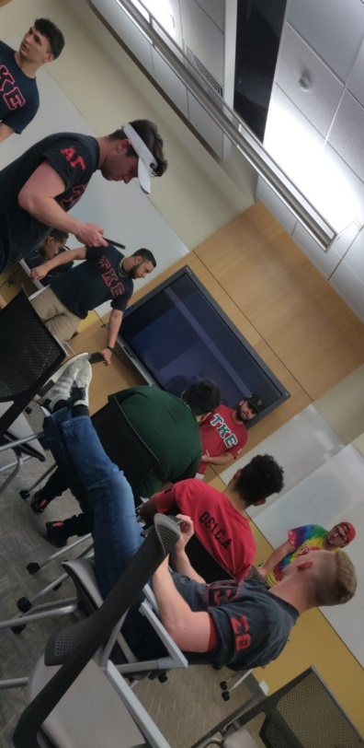
The Sigma Theta chapter decided on celebrating the Superbowl and making it a social event. The chapter ordered plenty of food, drinks, and had the entire room together dedicated to our entire campus.

Alumni Softball Game with Epsilon Beta Chapter
Histor Peter Pappalardo has got in-touch with Epsilon Beta chapter’s Histor George Jackson and proposed an Alumni Softball game between the two chapters. While this will be a competitive game, this will strengthen the relationship we have between our most nearby chapter. The game will take place on March 22nd, which is also part of Sigma theta’s first official Alumni Weekend of 2020!

Regional Leadership Conference Reflections
Tyler: “I had a really good time, and learned a lot from my sessions, specifically ritual. It was cool to see these new ideas that can make us successful”.
Thomas: “At RLC, their formal ritual showed how important ritual really was. Something I found interesting was how induction is the only time that a non-TKE can see the ritual. Some chapters can even invite parents and alumni. Other chapters have been more known to be business-related, which isn’t a bad thing at all”.
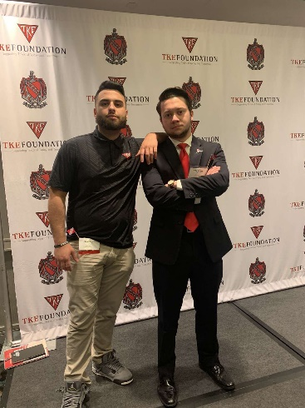
Bradley: “I enjoyed all the seminars. I met a lot of guys from other schools that had many great guys. Do what others can’t and show the magnitude of this great organization. TKE will always be there for the rest of your life. Another thing I learned too, the big writes a letter to their parents explaining why they chose them like a little brother”.
Jose: “One of the major things I learned was having conversations or arguments involve tone, mindsets, and reflections, and bargaining. You don’t always have to win an argument”.
Christian: “Resume critiques were my greatest thing to take away from RLC. I met a great guy named John Johnson, who gave me so much information. It was a great exchanging information on how to run a successful chapter. It was also important to note that some other chapters are better than us in certain situations”.
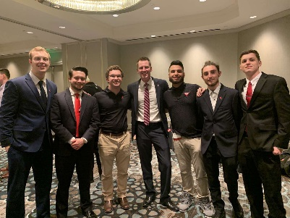
Brennan: “Atlanta was an awesome time. The one thing I took away most is recruitment. I wrote down many points, but finding the guys that have the what and why for the organization was easily the best advice I received”.
Andy: “Atlanta was a success. We got to meet a lot fo different people. A pylo from another chapter stuck out to me. He was given a task, and he went above and beyond. Its moments like these that show how great our image is. One of the most hated chapters was UCF, and yet they still recruit many. How did they do it? Through relationships with sororities. Making that connection is important and having them vouch only furthers that”.
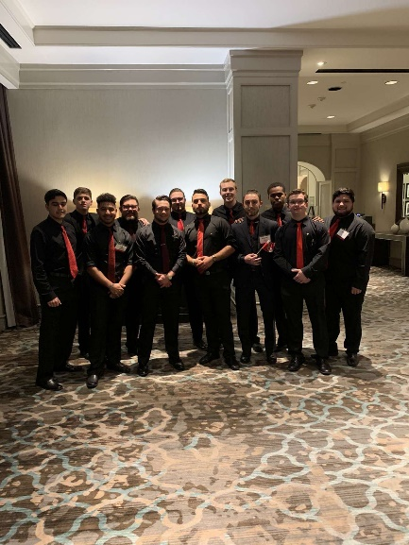
Charles: “The first thing I went to was Managing confrontation. You need to be more direct with individuals. You don’t want to grab attention. The Alumni table showed me that whenever the candidates get in, that they have to contact their grand bigs to show that their family lines are not dead”.
Evin: “I went to events pertaining to what I want to do within the chapter. I went to bond building events to strengthen our education. Mainly, Zach Bradley Brennan and I went to the same event. I am trying to put myself out there so I can eventually become Hegemon and doing whatever I can to get there”.
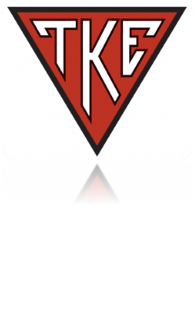
Zach: “This is my second time going. I was very inspired and got a lot of great information. I was super excited. I can sit back and take notes and focus on our issues. We talked about our culture, and RLC talked about building a championship culture. Culture is a reflection of your behaviors. New England is a winning culture, because when you go there, you witness their values and why they are thought of that way. This is what we should focus on daily. I am going to be talking about it each week from here on out trying to develop a culture and now start a new TKE of the week process. Visualize who you want to be. We want to be leaders and have potential, and we got it. We stuck with the people that we visualize who believe they need to be in this fraternity. It's super to remember that its We over Me. In this room, everyone has to make sacrifices sometimes. For you guys that want eBoard, selfless leaders are what you need to strive for. They said if you're a good leader, you're selfless. If you mess up, you are accountable for it”.

Retreats of 2020
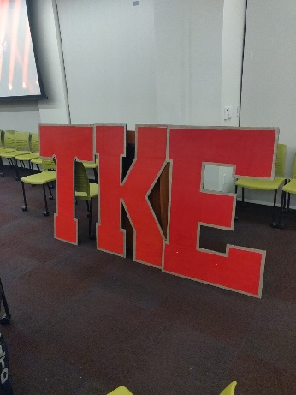
Hypophetes John-Paul West has planned to have two total retreats for this semester. Our first one has already been completed, and it has brought our organization very close together once more. While our first retreat this semester took around 5 hours to complete, JP’s second retreat is planned to be a one-night camping trip. This will consist of all the actives so that the chapter can celebrate a great year of recruitment and relationships between one another.
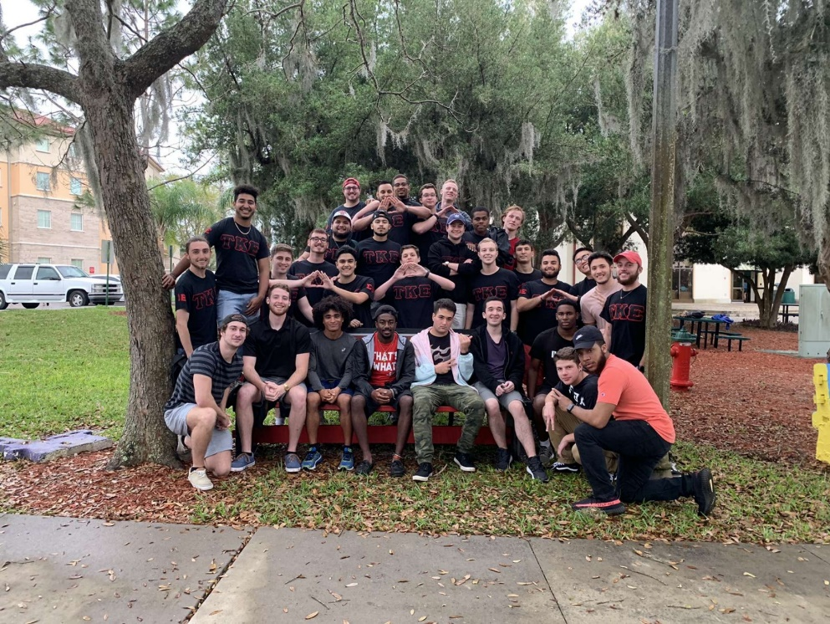
“Overall, I gathered as much of the actives I could to come to the retreat. It was a decent turnout. We did a more extensive version of the gavel pass giving people ample time to has out anything that’s neem on their minds especially anything involving a particular brother. I gave the option for a third party opinion to those who listened to the voiced issues and found solutions themselves or constructive comments. This went smoothly for the majority as there were rarely any disputes. I felt everyone knew they had the opportunity to be heard and took advantage of that finally.” – J-P West

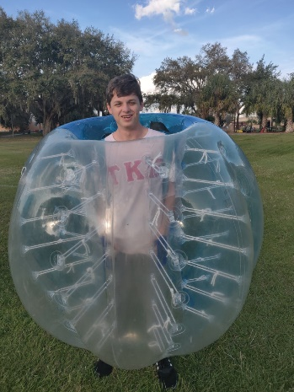
New Ritual/Induction Practice Meetings
Sigma theta Prytanis Zachary Smith has announced that our chapter will now be having dedicated practice meetings to conduct a ritual for both improving our image, and for portraying to the new class how vital of an event a Ritual meeting is. These practice meetings will, by far, strengthen us as a chapter and better-prepare us for when actual ritual events occur.

New Pylortes Strike System
Through unfortunate events for frater Michael Kiernan, frater Gabriel Schroeder has taken the role of Pylortes. While this was a slight adjustment to the board, Gabe has so far done an amazing job at preventing any disorder within the chapter. The executive board is extremely pleased to have him as he completely takes the job seriously and continuously works hard. Pylortes Gabe also created a new “strike system” to prevent any excess conversations or interruptions within the organization. This forces the organization to become more productive and efficient in not just Chapter, but for all meetings as well.
“I feel that my work on pylo has been great for the organization. My system is effective. However, it does make people a little irritated, but at least the chapter is more orderly”. – Gabe Schroeder

Rush Week Shirts for the Alumni
Part of our previous Rush Week involved the production of Rush Week shirts. This helped in showing better awareness across campus. While many shirts were sold, rush and social chair, Bradley Pincus, reports that there is still plenty left. All alumni are still advised to purchase any shirt of any size! If anyone wishes to order any shirts, please make sure to reach out to Bradley for details!

End of Newsletter

