Introduction
The year 2018-2019 was an extreme accomplishment for our chapter. No matter what curve ball was bound to hit us, all members remained strong and smart.

Spring Class
“Better Men for a Better World”
  - SIGMA THETA
2 April 2019
We were utterly successful with Spring’s recruitment and the class we have developed. However, a class of 19 members dropped to 17. Initiates Nicholas Quinones and Nick Cupo have both dropped due to their respective issues that had produced conflictual errors in regards to their process. As for the other 17, they have gotten through their process with high motivation and effort.

Tau Kappa

Epsilon Newsletter

Sigma Theta Very Successful
This past year consisted of very constructive moments for us to look back on:
- Recruiting a class of 17 members
- An easily-won mock rock concert
- Putting University of Tampa in its place
- 2nd place in Greek Week
- Kevin Sulivan’s agreement
And much more…

Name: Austin Wentz
Position: Prytanis
Congratulations to the new E-Board!!!
Name: Zachary Smith
Position: Epi-prytanis
Name: Tyler Bourdeau
Position: Grammateus
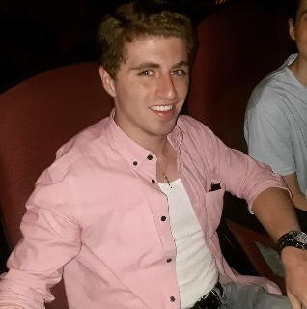
Name: Peter Pappalardo
Position: Histor
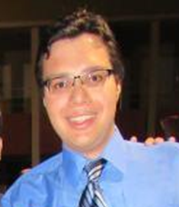
Name: Eduard De La Luz
Position: Crysophylos

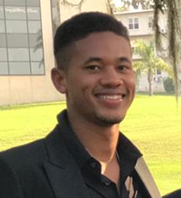
Name: John-Paul West
Position: Hypophetes
Name: Michael Kiernan
Position: Pylortes
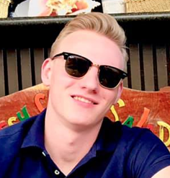
Name: Christopher Kosarzycki
Position: Hegemon

The Executive Board of 2018-2019
The Sigma Theta chapter E-Board of 2018-2019 deserves some recognition for their hard work and effort. Their succession needs to be remembered, as their motivation and professionalism made a huge impact on our chapter. Because their jobs were done efficiently and effectively, each member deserves some individual commendation.

Jason Delaney - as the president for the organization, Jason has done an incredible job at keeping our chapter out of trouble, consistently wearing letters around campus, and maintaining a professional attitude amongst the rest of Saint Leo. His presence gave Tau Kappa Epsilon a very proficient and successful image, and yet that is only one of the many things in which Jason nailed. His parental figure will set as a guide for the next coming generations that Sigma Theta will forever acquire.
Ryan Bourdeau – With high motivation and always being a major TKE face around campus, Ryan did an awesome job at making sure our organization exceeded the requirements necessary. For any events that in which would currently happen, Ryan made sure the news was out and that most, if not everyone, could attend. Ryan also did a great job at making Jason’s obligation a whole lot easier, hence allowing the head of our chapter to have a lighter responsibility load so that our chapter can maintain expertise.
Maxwell Kizewski – Being thrown into the position of Grammateus was no doubt a challenge, especially when it was right after going through a process. Out of the whole Alpha Gamma (gay) class, Max was easily the only viable option to handle this position effectively. Not to mention, his ties with Residence Life gave our chapter an advantage on utilizing extra safety precautions. He did an awesome job at keeping track of everyone’s attendance and what important information needed to be recorded.
Taylor Bauer – Once again, Taylor’s familiarity with this position kept the chapter at the best standing possible. His coordination with Jason allowed the chapter to consistently be stressed on how imperative dues are in regards to our culture and influence. Without our dues being strained upon, we could not have performed the tasks we did. Taylor also gave a superb 20-minute class to the E-Board pre-nominations meeting. This deserved a major shout-out as it was probably one of the funniest, yet informative, speeches to ever witness.
Wanit Ruekit – Although Wanit has a very busy schedule, his position as Histor was a perfect balance for him so that he could contribute to the fraternity while handling his intense workload. Mentioning important updates on top of generating a very organized template for newsletters made his position as Histor successful. Wanit also taking this position helped sustain the Histor family line!
Adam Alexander – As hypophetes, it is important to be able to cope with all the members, and Adam was able to do just that. For the new spring class, Adam has done an excellent job of introducing retreat ideas and bonding experiences. As one of the older class members, Adam is highly familiar with the fraternity and the issues that might come across him; he’s seen it all and understands how it must be dealt with. Without his aid, the chapter would not be able to communicate professionally.
Zachary Smith – Zach’s position as Pylortes had a very successful run in many aspects. Zach took every chapter meeting seriously. Therefore, this helped Jason in maintaining order in the chapter room. Zach is easily one of the most motivated actives of TKE, and this was reflected through his understanding of preventing our chapter from endangering ourselves.
Gregory Miller – Greg is a vital asset to our continuation of the chapter. Keeping control of a class of 17 possible members was never an easy job to handle. Greg did an excellent job at preventing any potential members from getting into trouble as well as teaching them important information regarding our organization.

