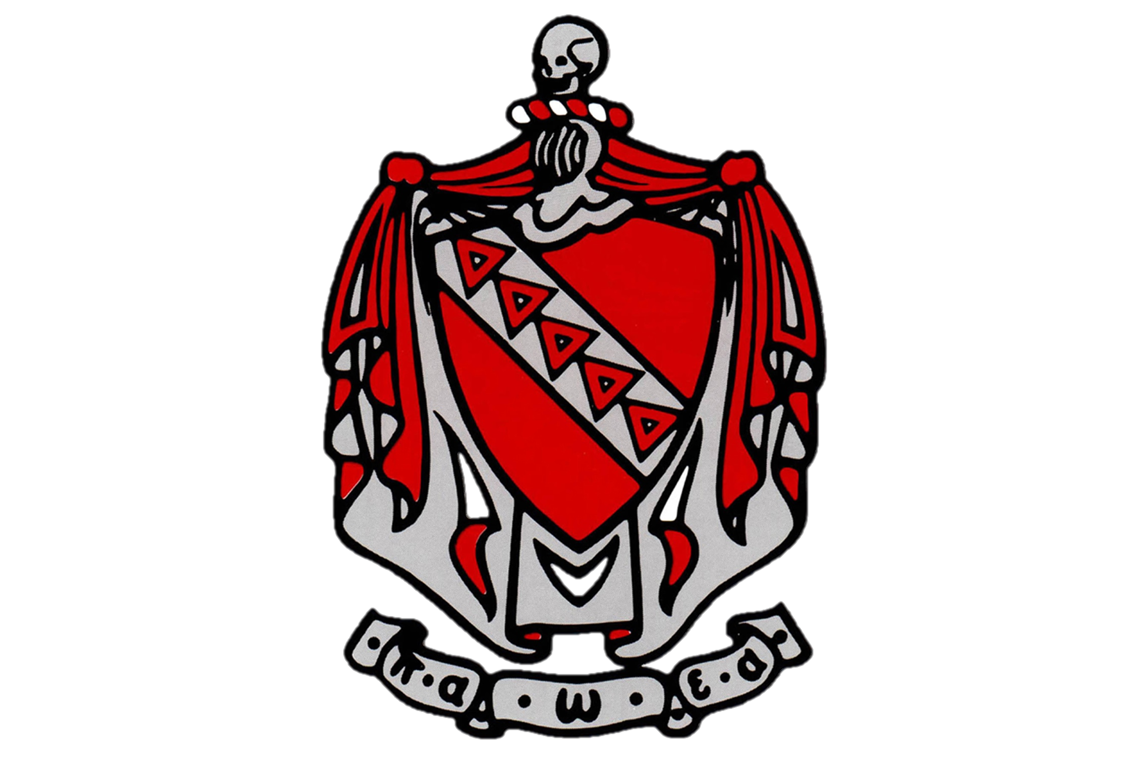

End of the Year Newsletter

TKE Tau Phi Newsletter



Tau Phi

Newsletter

From Boys to Men

**New Member Inductions**

This past spring we were fortunate enough to add 5 proud members to Tau Phi’s brotherhood. Although they spent a good portion of the second term being disgusting and vile, they all made miraculous turnarounds on March 19th at approximately 8:30 am. Having started as 5 strangers, these gentlemen turned into an incredibly close knit group that hope to be strong additions in the years to come.

**Matthew Gabrin**

Pictured to the left is frater Matthew Gabrin. Despite his hatred for the pledging process, Matt has been a great addition and his stingy personality should make him a great Crysopolis.

**Brian Bevan**

Pictured to the left is frater Brian Bevan. Originally from Las Vega, our former news anchor is always a great time. We look forward to having him as our new Social Chair!





**Nick Kiger**

Pictured to the left is frater Nick Kiger. Thankfully, he’s come out of his shell since the start of the pledging process. Through a love of hockey and hatred of his roommate Josh, Nick quickly became a favorite among the new members.

**Ryan Gabrin**

Pictured to the left is yours truly. Voted “Best Gabrin” at last year’s RCB, I hope to continue my reign and look forward to serving as this year’s Histor.

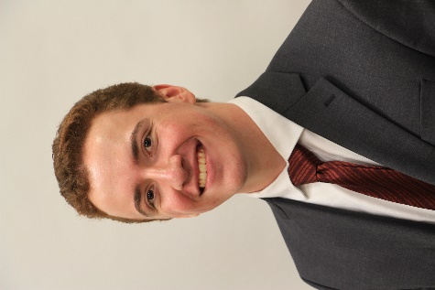

**Joshua Miller**

Pictured to the left is frater Joshua Miller. Despite his awful hairstyles, Josh is a kind hearted and overall nice guy. We hope his organizational skills will help make his a great Grammateus this coming year!





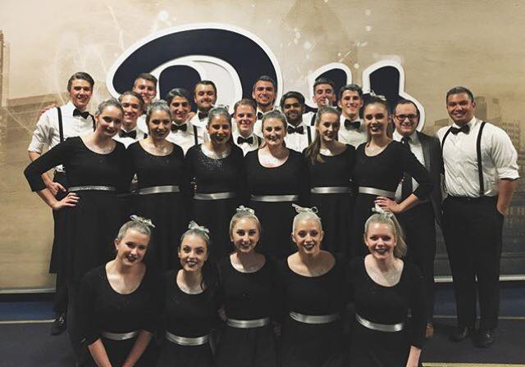

Tau Phi

Newsletter

Paired with Theta Phi Alpha, Sigma Beta Rho, and Triangle, this year’s Greek Sing brought the house down. After their many months of practice and long nights, it all came together perfectly. Despite the terrifying look of some of our members with the grey hair and eyeshadow, all in all the night turned out a success.

Congratulations to Dom, Sam, Nick, Ethan, and Adam on their great performances. Following the performance, the mixer at Triangle was unfortunately cut short, but the night was still a success if only because Nick Trondavi somehow managed to stumble home unharmed. Although we didn’t leave the stage with any awards, Greek Sing helped us create a fantastic relationship with the girls of TPA and was surely a night to be proud of!

Welcome to the Twilight Zone

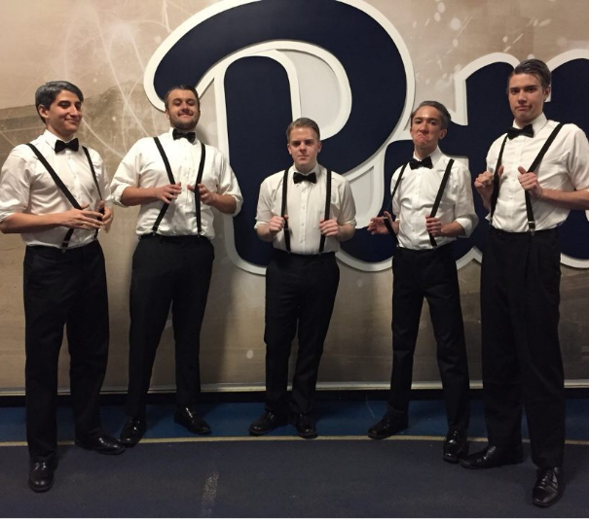

**Greek Sing**

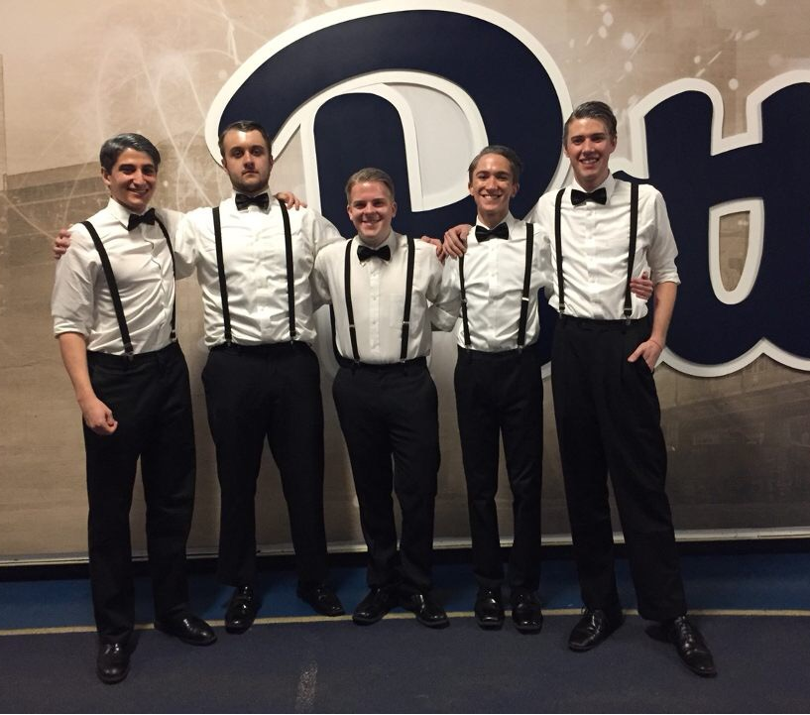



**Red Carnation Ball**

Rounding Out the Year

Tau Phi

Newsletter

**Other Notable Awards**

* **Nick Kiger – First Ever Chik-Fil-A Tolerance Scholarship**
* **JT Delic – Stone Cold Steve Austin Biggest Fan Award**
* **Matthew Gabrin – Hellen Keller Award**

This year’s RCB was one to be remembered. Planned by the one and only Torsten Voigt, we had an impressive turnout despite the short notice given to the alumni that we were sure to hear about. Hosted by none other than our former Hegemon Sam Philips and former Prytanis Dominic Disanto, it was surely everything we could have hoped for. This year’s notable awards were Top Scholar, awarded to new Prytanis Ethan Marra, “Johnny Drink ‘Em All”, awarded to Julian Mandzy, and the Red Carnation, awarded to none other than Dom Disanto. Despite a rowdy neighboring event who was allegedly responsible for the puke at our door, the night went off without a hitch!

**Tau Phi Sweetheart**

To round out our year, the active members of the Tau Phi chapter met one last time to elect our newest chapter sweetheart. Through the user of bribery in the form of chocolate chip cookies, Caroline Drake of Theta Phi Alpha earned the chapter’s vote! Pictured to the right, she is a Psychology major originally from Chicago, Illinois who aspires to one day become a Pediatric Occupational Therapist. Her favorite hobby is reportedly baking, and when asked why she loves TKE she said the following: “I love TKE because everyone is so genuine and fun to be around. Whether it’s studying in Hillman, watching a movie, or losing at bowling, I am always laughing and having fun with the brothers.”





Tau Phi

Newsletter

Contact Information



**Prytanis**

Ethan Marra

[epm23@pitt.edu](mailto:epm23@pitt.edu)



**Social Chair**

Brian Bevan

[bmb134@pitt.edu](mailto:bmb134@pitt.edu)



**Recruitment Chair**

Dominic Disanto

[jdd65@pitt.edu](mailto:jdd65@pitt.edu)

**Epiprytanis**

Sean Fulton

[srf34@pitt.edu](mailto:srf34@pitt.edu)



**Hypophetes**

Torsten Voigt

[tdv5@pitt.edu](mailto:tdv5@pitt.edu)

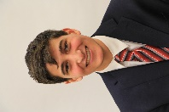

**Philanthropy Chair**

JT Delic

[jtd52@pitt.edu](mailto:jtd52@pitt.edu)

**Crysopolis**

Matthew Gabrin

[mag313@pitt.edu](mailto:mag313@pitt.edu)

**Grammateus**

Joshua Miller

[jom149@pitt.edu](mailto:jom149@pitt.edu)

**Pylortes**

Kyle Huber

[kwh18@pitt.edu](mailto:kwh18@pitt.edu)

**Histor**

Ryan Gabrin

[rjg69@pitt.edu](mailto:rjg69@pitt.edu)

**Hegemon**

Nick Tondravi

[nit28@pitt.edu](mailto:nit28@pitt.edu)

**Letter From the Histor**

Hello everyone!

I look forward to this year as your Histor, and welcome any feedback you guys might have. If you’d like more added to the newsletter, have any suggestions for next year’s TKE’sgiving, or would like to be a part of planning our next RCB, feel free to reach out to me with the information below. As for the alumni reading this message, any way I can help make it easier for you guys to stay involved with the chapter, please let me know. Except for if your request is for an earlier heads up about RCB. I know. I look forward to a great year with everyone!

YITB,

Ryan Gabrin

(412) 719-7415

[rjg69@pitt.edu](mailto:rjg69@pitt.edu)